⚙️ Odoo Configuration Guide

🛠 Installation Requirements

**Python 3.10**

🔗 [Download Python 3.10](https://www.python.org/downloads/release/python-3100/)

**Visual Studio Build Tools**

🔗 [Download vsBuildTools](https://visualstudio.microsoft.com/downloads/)

**PostgreSQL**

🔗 [Download PostgreSQL](https://www.enterprisedb.com/downloads/postgres-postgresql-downloads)

📌 Add PostgreSQL bin to PATH:

`C:\Program Files\PostgreSQL\<version>\bin`

**PyCharm Community Edition**

🔗 [Download PyCharm](https://www.jetbrains.com/pycharm/download/?section=windows)

**Odoo Version clone use git base**

git clone [https://github.com/odoo/odoo.git -b 18.0 --depth 1](https://github.com/odoo/odoo.git%20-b%2018.0%20--depth%201)

git clone [https://github.com/odoo/odoo.git -b 17.0 --depth 1](https://github.com/odoo/odoo.git%20-b%2017.0%20--depth%201)

git clone [https://github.com/odoo/odoo.git -b 16.0 --depth 1](https://github.com/odoo/odoo.git%20-b%2016.0%20--depth%201)

git clone [https://github.com/odoo/odoo.git -b 15.0 --depth 1](https://github.com/odoo/odoo.git%20-b%2015.0%20--depth%201)

git clone [https://github.com/odoo/odoo.git -b 14.0 --depth 1](https://github.com/odoo/odoo.git%20-b%2014.0%20--depth%201)

🖥 Development Environment Setup

1. Project Configuration

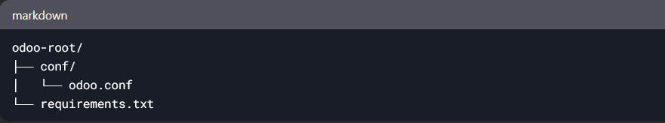

2. odoo.conf File

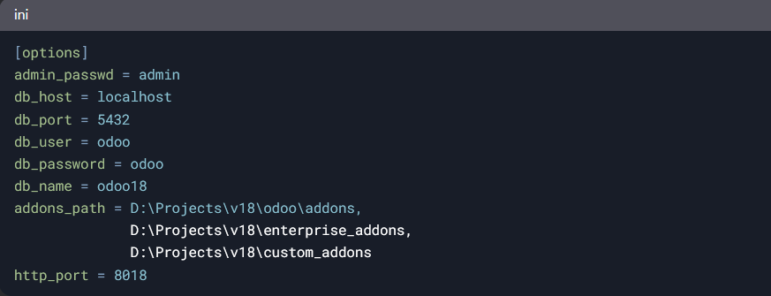

3. pgAdmin

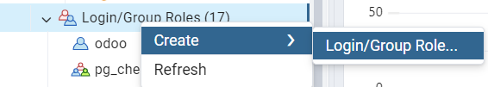

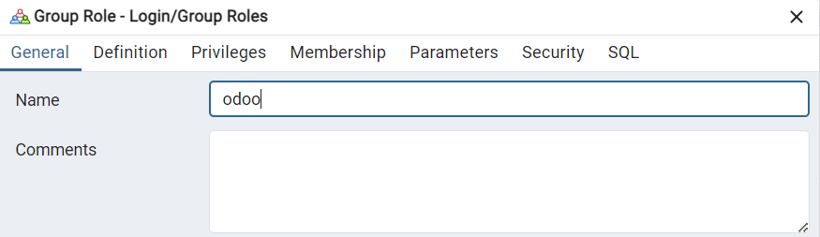

Password : odoo

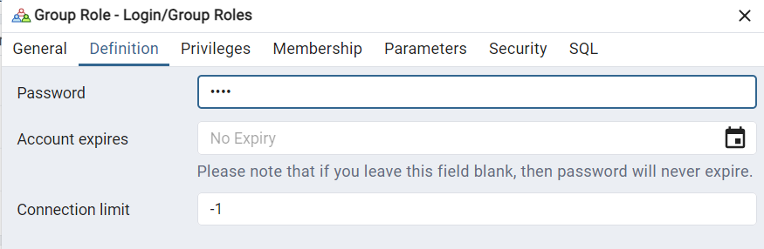

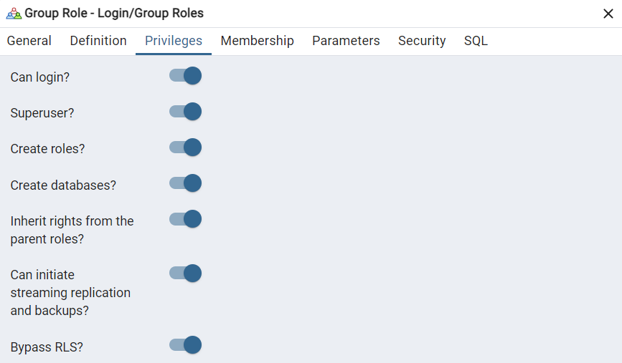

Click Save



4. PyCharm Setup

**Python Interpreter**

Open Pycharm settings menu

Enter project menu

Select Python Interpriter [add loacl Interpriter]

**Run Configuration**

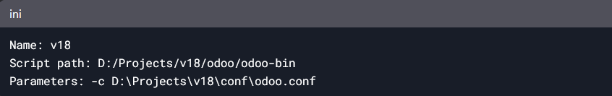

📦 Dependency Management

**requirements.txt**

Babel==2.9.1 # min version = 2.6.0 (Focal with security backports)  
chardet==3.0.4  
# cryptography==3.4.8  
cryptography==3.4.8; python_version < '3.12' # incompatibility between pyopenssl 19.0.0 and cryptography>=37.0.0  
cryptography==42.0.8 ; python_version >= '3.12' # (Noble) min 41.0.7, pinning 42.0.8 for security fixes  
decorator==4.4.2  
docutils==0.16  
ebaysdk==2.1.5  
# freezegun==0.3.11; python_version < '3.8'  
freezegun==0.3.15; python_version >= '3.8'  
gevent==1.5.0 ; python_version == '3.7'  
gevent==20.9.0 ; python_version > '3.7' and python_version <= '3.9'  
gevent ; python_version > '3.9' # (Jammy)  
greenlet==0.4.15 ; python_version == '3.7'  
greenlet==0.4.17 ; python_version > '3.7' and python_version <= '3.9'  
greenlet ; python_version > '3.9' # (Jammy)  
idna==2.8  
Jinja2==2.11.3 # min version = 2.10.1 (Focal - with security backports)  
libsass  
lxml==4.8.0 # min version = 4.5.0 (Focal - with security backports)  
MarkupSafe==1.1.0  
num2words==0.5.6  
ofxparse==0.19; python_version <= '3.9'  
ofxparse==0.21; python_version > '3.9' # (Jammy)  
passlib==1.7.3 # min version = 1.7.2 (Focal with security backports)  
Pillow # min version = 7.0.0 (Focal with security backports)  
polib==1.1.0  
psutil # min version = 5.5.1 (Focal with security backports)  
psycopg2==2.9.2 ; python_version == '3.10' # (Jammy)  
psycopg2==2.9.5 ; python_version == '3.11'  
psycopg2==2.9.9 ; python_version >= '3.12' # (Noble) Mostly to have a wheel package  
pydot==1.4.1  
pyopenssl==19.0.0  
PyPDF2==1.26.0  
pypiwin32 ; sys_platform == 'win32'  
pyserial==3.4  
python-dateutil==2.7.3  
python-ldap==3.4.0 ; sys_platform != 'win32' # min version = 3.2.0 (Focal with security backports)  
python-stdnum==1.13  
pytz==2019.3  
pyusb==1.0.2  
qrcode==6.1  
reportlab # version < 3.5.54 are not compatible with Pillow 8.1.2 and 3.5.59 is bullseye  
requests==2.25.1 # versions < 2.25 aren't compatible w/ urllib3 1.26. Bullseye = 2.25.1. min version = 2.22.0 (Focal)  
urllib3==1.26.5 # indirect / min version = 1.25.8 (Focal with security backports)  
vobject==0.9.6.1  
Werkzeug==0.16.1 ; python_version <= '3.9'  
Werkzeug==2.0.2 ; python_version > '3.9' # (Jammy)  
xlrd==1.1.0; python_version < '3.8'  
xlrd==1.2.0; python_version >= '3.8'  
XlsxWriter==1.1.2  
xlwt==1.3.*  
zeep==3.4.0  
rjsmin

**Installation Command:**

cd open_odoo_version_root_folder

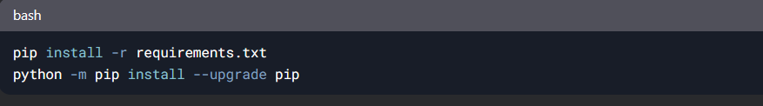

🚀 Running Odoo

**Other Terminal Command [Optional]**

pip install lxml

pip install psycopg2-binary

pip install psycopg2

pip install pdfminer.six

pip install --upgrade django geoip2

pip install pyjwt

pip install python-stdnum

pip install --upgrade python-stdnum

pip install phonenumbers

python odoo-bin –version # check odoo version

# start shell using terminal

python odoo-bin shell -c D:\Apps\odoo-17.0\conf\odoo.conf -d odoo17

**If add enterprise**

-c D:\Projects\v18\conf\odoo.conf **-d database_name -u all**

**Example odoo.conf File [Oprional]:**

[options]

**; Server configuration**

port = 8069

host = 0.0.0.0

workers = 2

**; Database configuration**

db_host = 127.0.0.1

db_port = 5432

db_user = odoo

db_password = my_secure_password

**; Addons path**

addons_path = /opt/odoo/addons,/opt/odoo/custom_addons

**; Logging**

logfile = /var/log/odoo/odoo.log

log_level = info

**; Security**

admin_passwd = admin123

**; Email configuration**

smtp_server = smtp.gmail.com

smtp_port = 587

smtp_user = your_email@gmail.com

smtp_password = your_password

**Jump on data base manager url**

<http://localhost:8014/web/database/manager>

**Start PostgreSQL in terminal**

psql -h localhost -U postgres -d odoo17

Password for user postgres: postgres

**If work in restore data base**

update ir_cron set active = false;

update res_users set login='admin', password='admin' where id =2;

update ir_cron set active=False where active=True

update res_partner set email='your_email'

update ir_mail_server set active=False

Update fetchmail_server set active=False